Store and Retrieve a File with [Amazon S3](https://aws.amazon.com/s3/)

This step-by-step tutorial will help you store your files in the cloud using Amazon Simple Storage Solution (S3). Amazon S3 is a service that enables you to store your data (referred to as *objects*) in at massive scale. In this tutorial, you will create an Amazon S3 bucket, upload a file, retrieve the file and delete the file.

## **Step 1. Enter the Amazon S3 Console**

When you [click here](https://console.aws.amazon.com/console/home), the AWS Management Console will open in a new browser window, so you can keep this step-by-step guide open.  When the screen loads, enter your user name and password to get started. Then type *S3* in the search bar and select S3 to open the console.

(click to zoom) 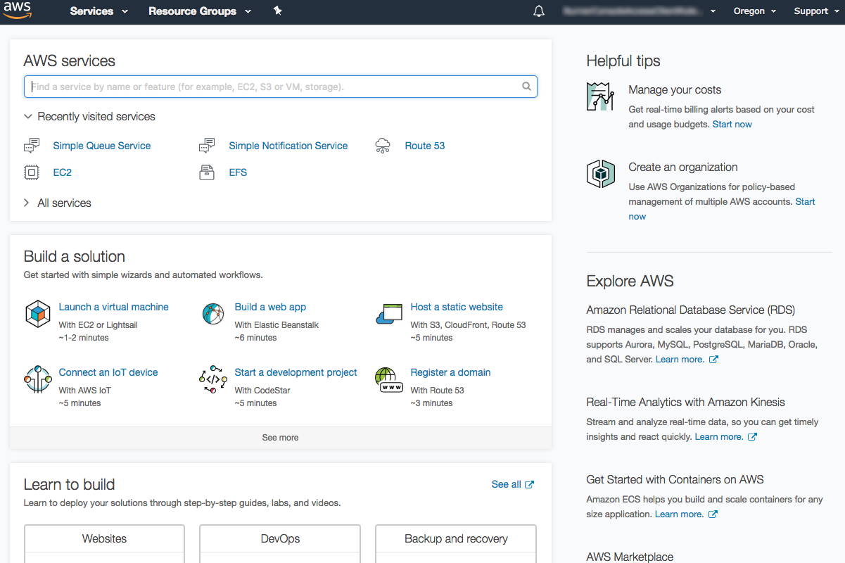

## **Step 2. Create an S3 Bucket**

In this step, you will create an Amazon S3 *bucket*. A bucket is the container you store your files in.

a.  In the S3 dashboard, click Create Bucket.

If this is the first time you have created a bucket, you will see a screen that looks like the image pictured here.

If you have already created S3 buckets, your S3 dashboard will list all the buckets you have created.

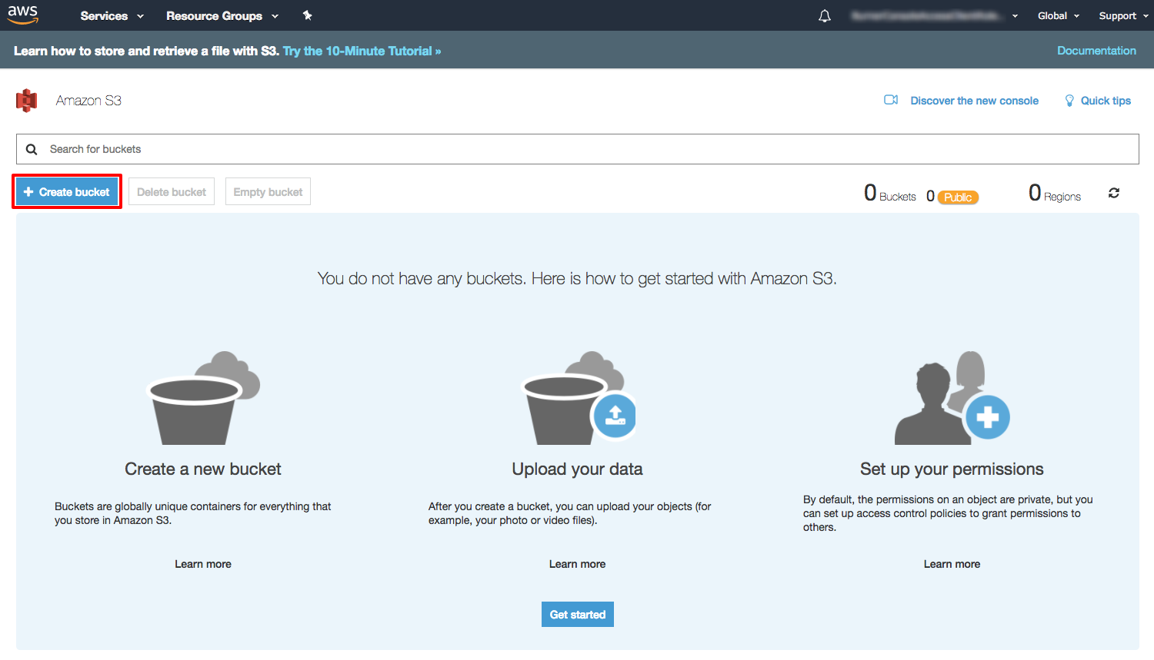

(click to zoom)

b. Enter a bucket name. Bucket names must be unique across all existing bucket names in Amazon S3. There are a number of other [restrictions on S3 bucket names](http://docs.aws.amazon.com/AmazonS3/latest/dev/BucketRestrictions.html) as well. Then select a region to create your bucket in.

Select Next.

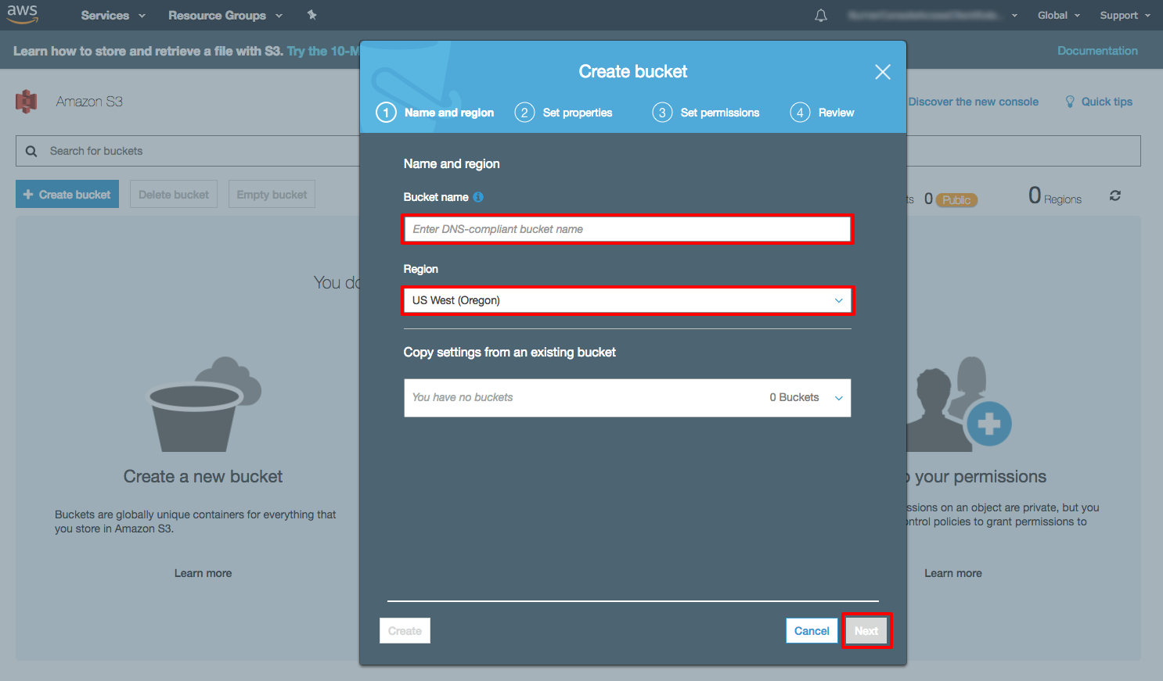

(click to zoom)

c.  You have many useful options for your S3 bucket including [Versioning](http://docs.aws.amazon.com/AmazonS3/latest/dev/Versioning.html), [Server Access Logging](http://docs.aws.amazon.com/AmazonS3/latest/user-guide/server-access-logging.html), [Tags](https://docs.aws.amazon.com/AmazonS3/latest/dev/BucketBilling.html), [Object-level Logging](https://docs.aws.amazon.com/awscloudtrail/latest/userguide/logging-management-and-data-events-with-cloudtrail.html?icmpid=docs_cloudtrail_console#logging-data-events) and [Default Encryption](https://docs.aws.amazon.com/AmazonS3/latest/dev/bucket-encryption.html). We won't enable them for this tutorial. Select Next.

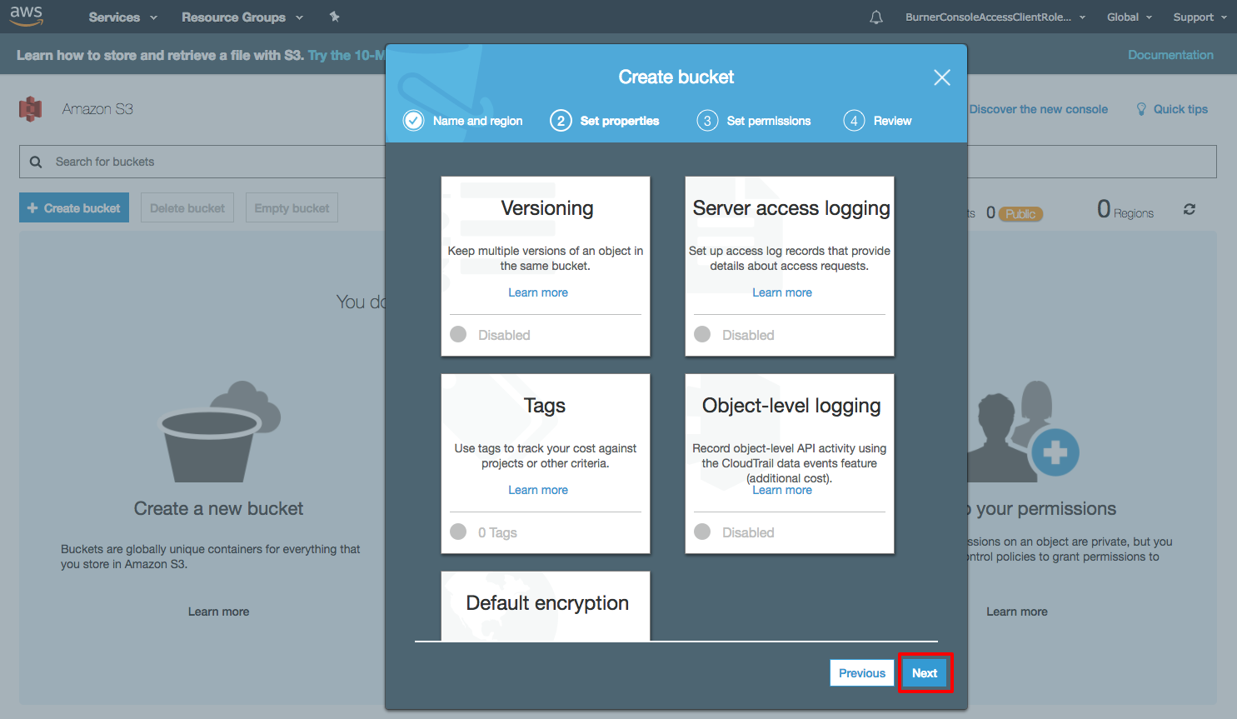

(click to zoom)

d. You have the ability to set permission settings for your S3 bucket. Leave the default values and select Next.

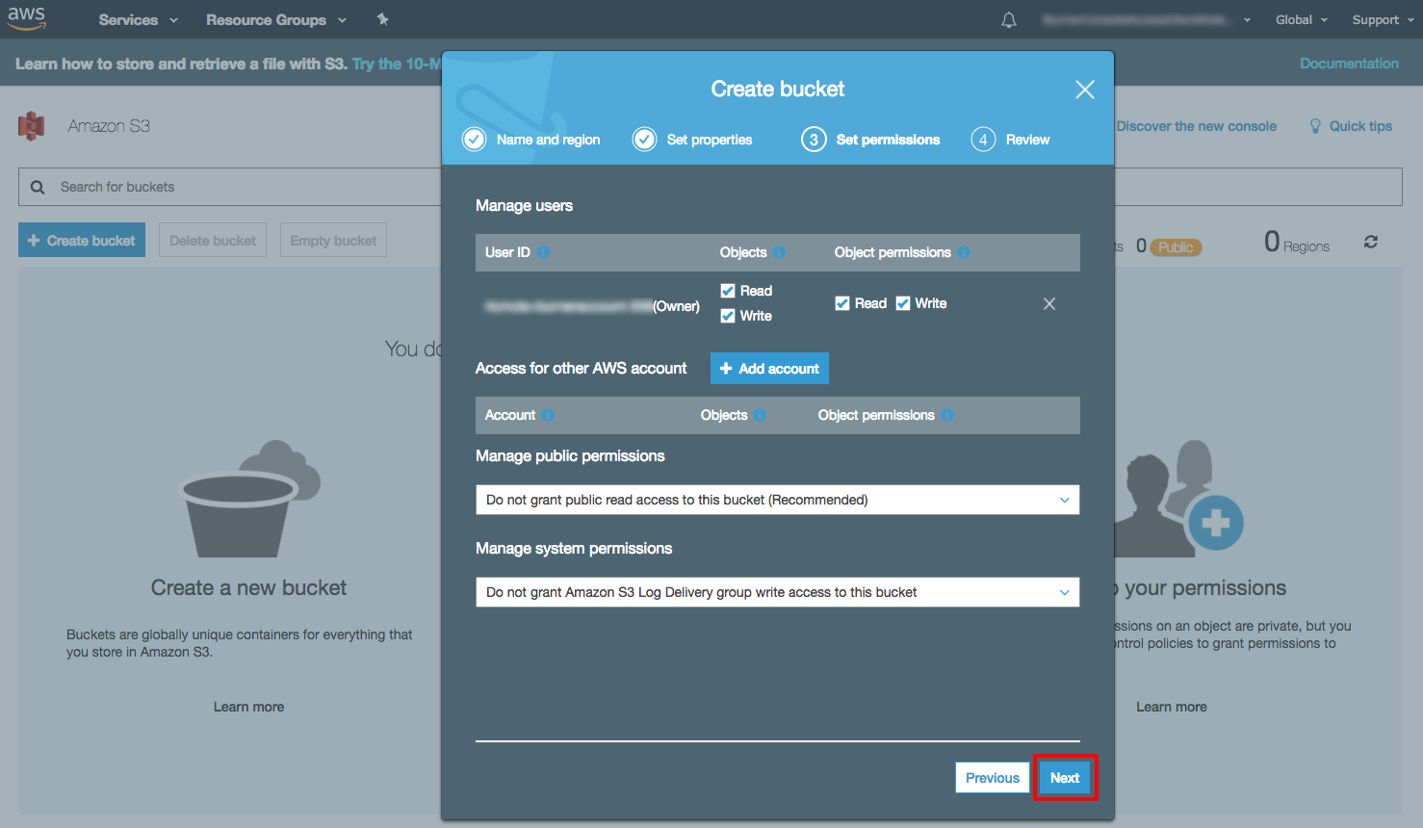

(click to zoom)

e.  Review your configuration settings and select Create bucket.

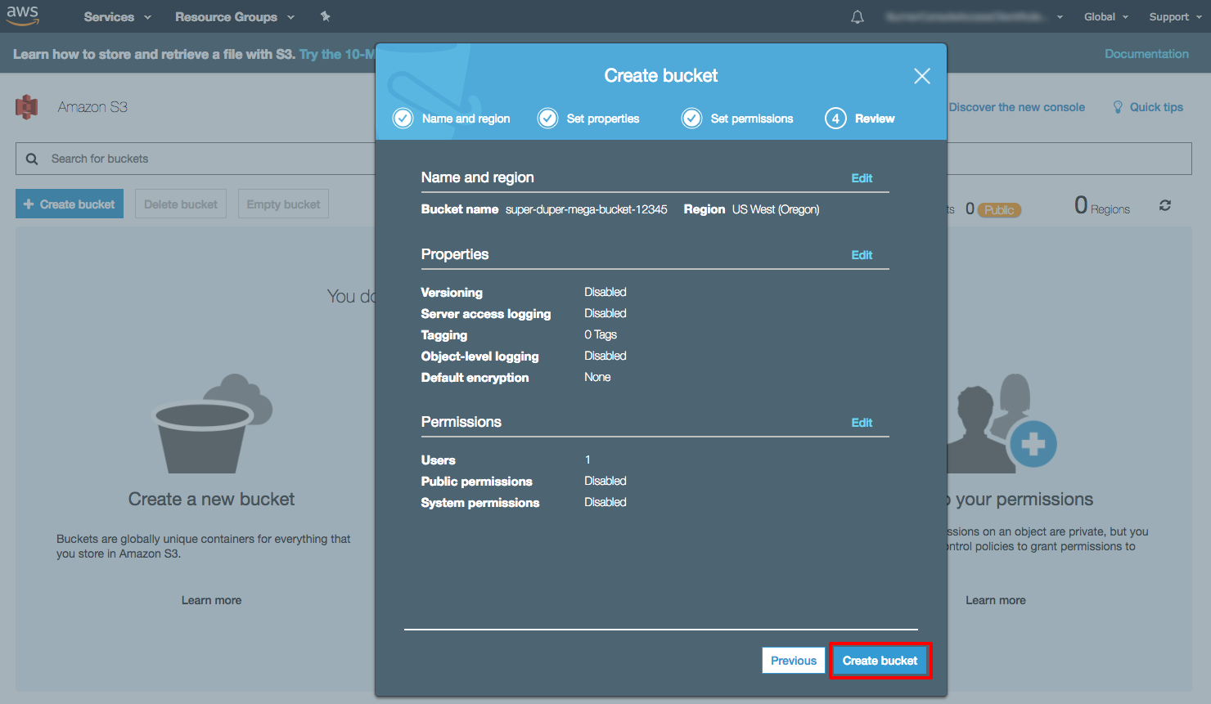

(click to zoom)

## 

## **Step 3. Upload a File**

In this step, you will upload a file to your new Amazon S3 bucket.

a.  You will see your new bucket in the S3 console. Click on your bucket’s name to navigate to the bucket.

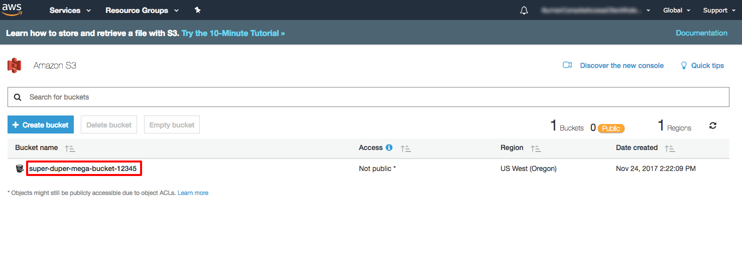

(click to zoom)

b.  You are in your bucket’s home page. Select Upload.

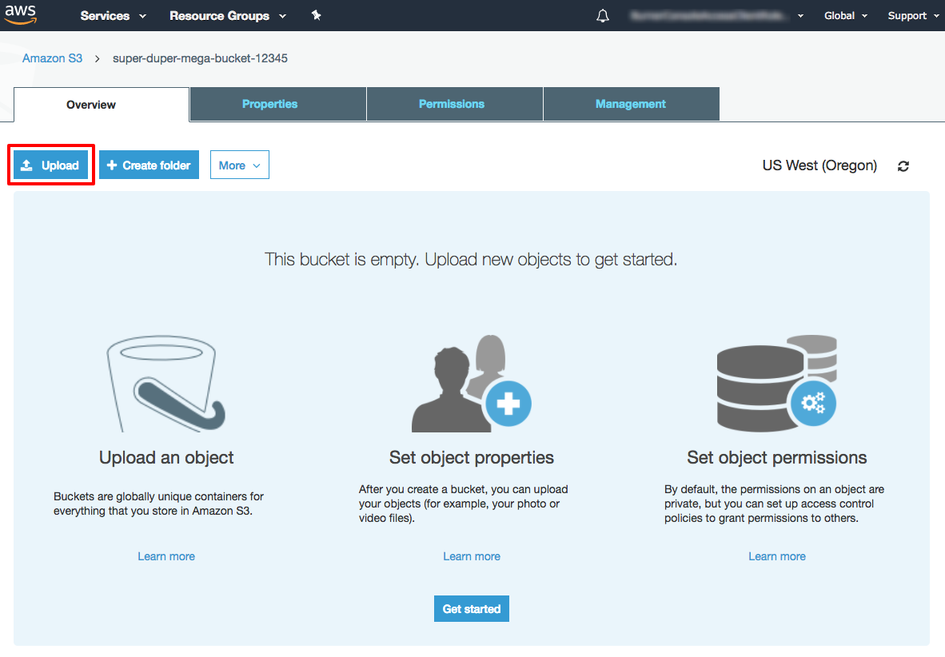

(click to zoom)

c. To select a file to upload, either click Add files and select a sample file that you would like to store OR Drag and Drop a file on the upload box. Select Next after you have selected a file to upload.

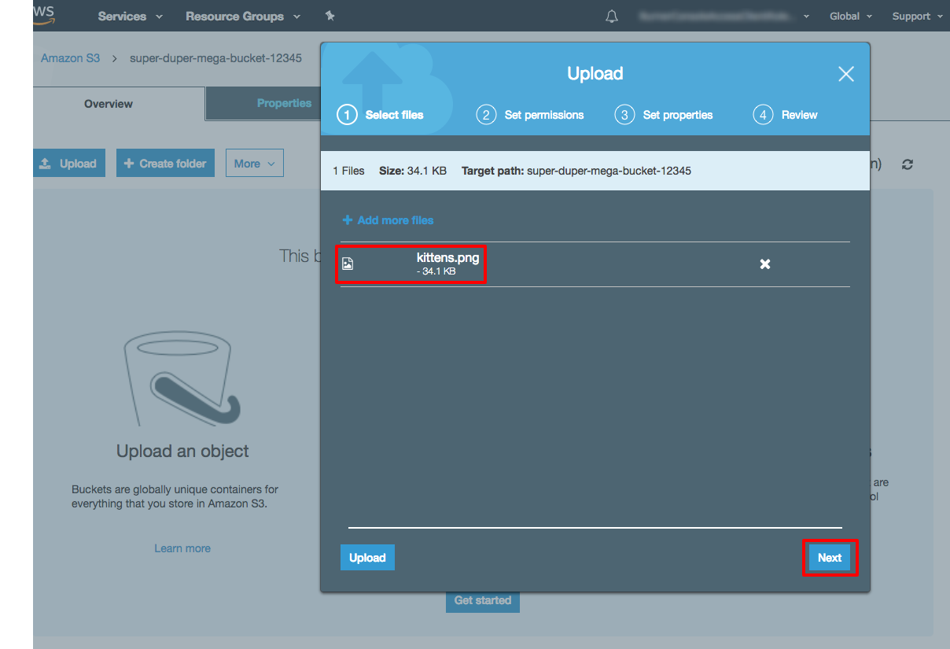

(click to zoom)

d. You have the ability to set permission settings on your object. For this tutorial, leave the default values and select Next.

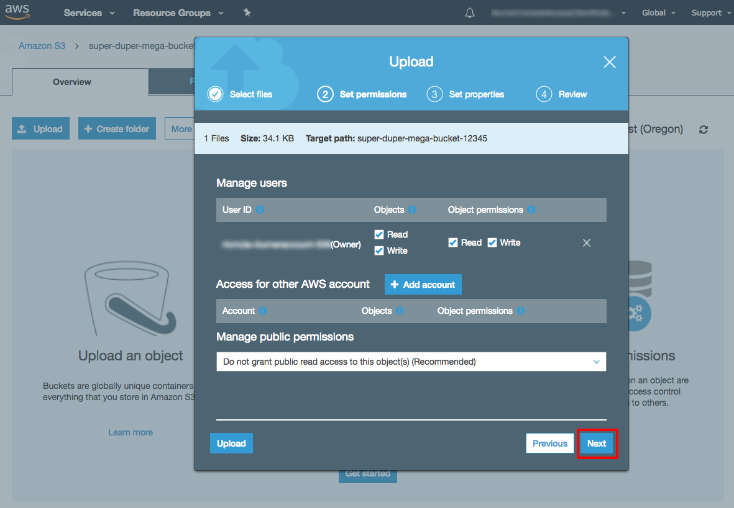

(click to zoom)

e. You have the ability to set property settings like storage class, encryption, and metadata with your object. Leave the default values and select Next.

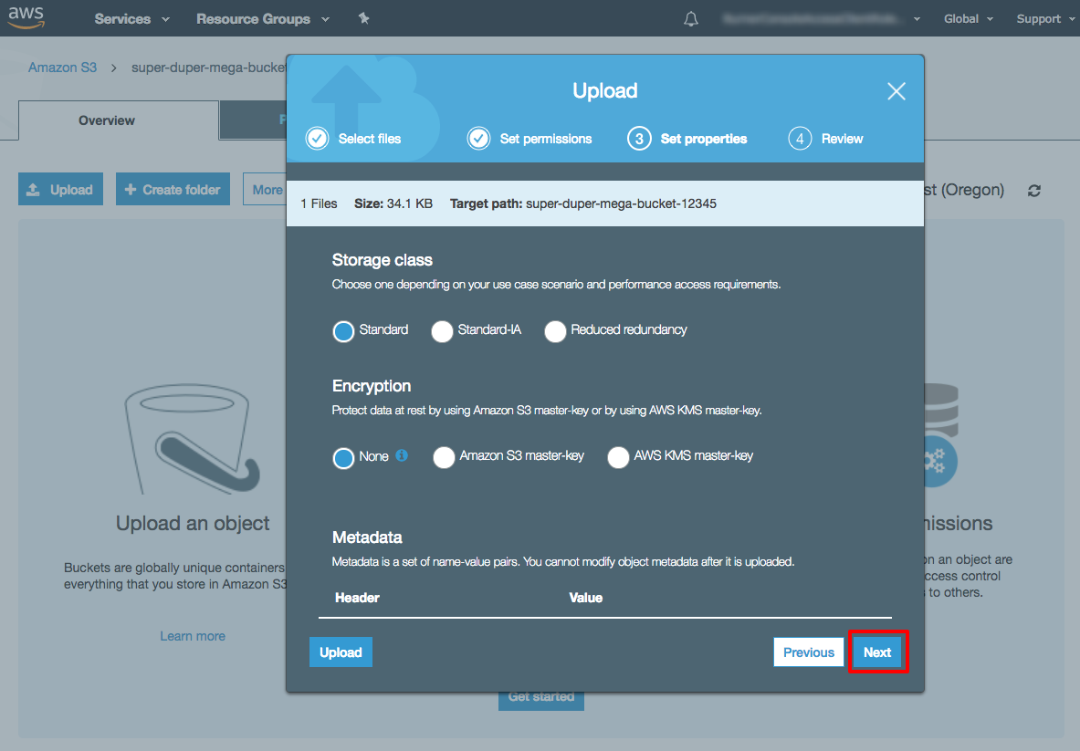

(click to zoom)

f. Review your configurations and select Upload. You will see your object in your bucket’s home screen.

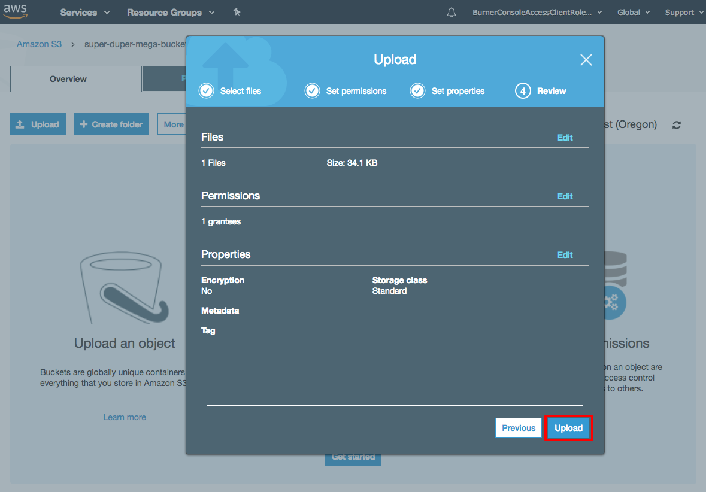

(click to zoom)

## **Step 4: Retrieve the Object**

In this step, you will download the file from your Amazon S3 bucket.

a. Select the checkbox next to the file you would like to download, then select Download.

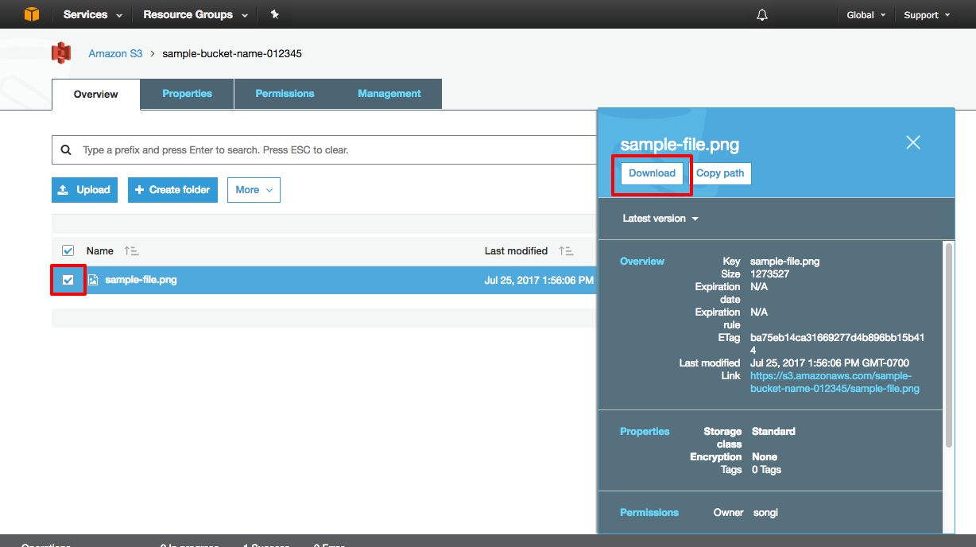

(click to zoom)

## **Step 5: Delete the Object and Bucket**

You can easily delete your object and bucket from the Amazon S3 console. In fact, it is a best practice to delete resources you are no longer using so you don’t keep getting charged for them.

a. You will first delete your object. Select the checkbox next to the file you want to delete and select More > Delete.

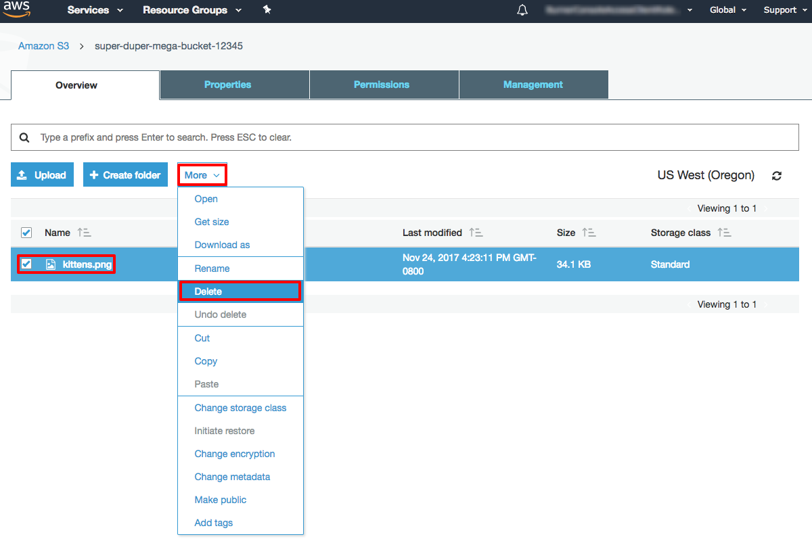

(click to zoom)

b.  Review and confirm the object you want to delete. Select Delete.

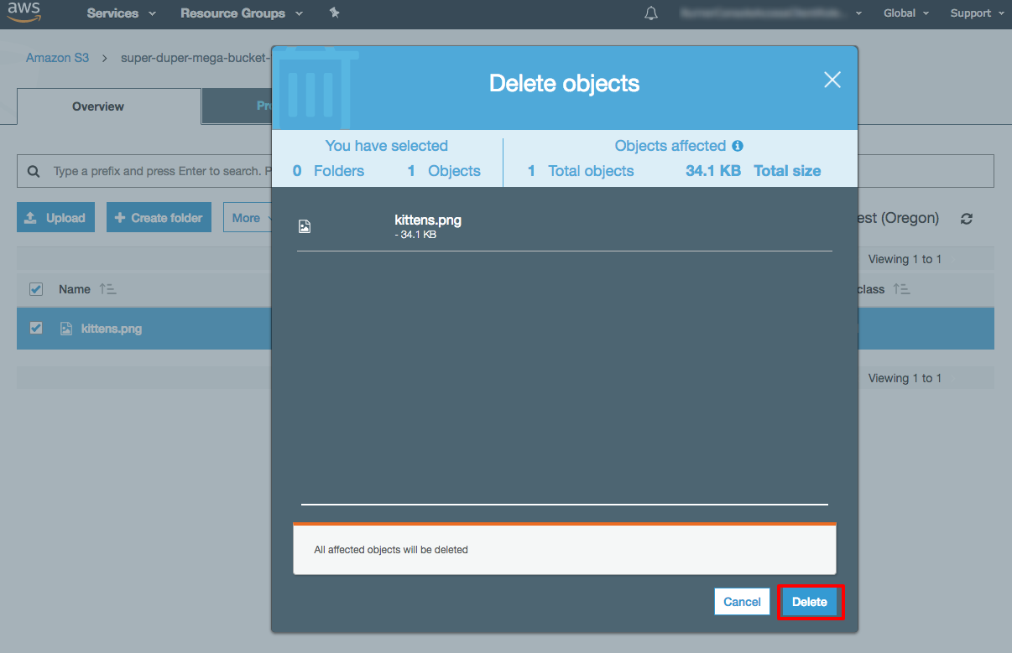

(click to zoom)

c. Click on Amazon S3 to view all your buckets in the region.

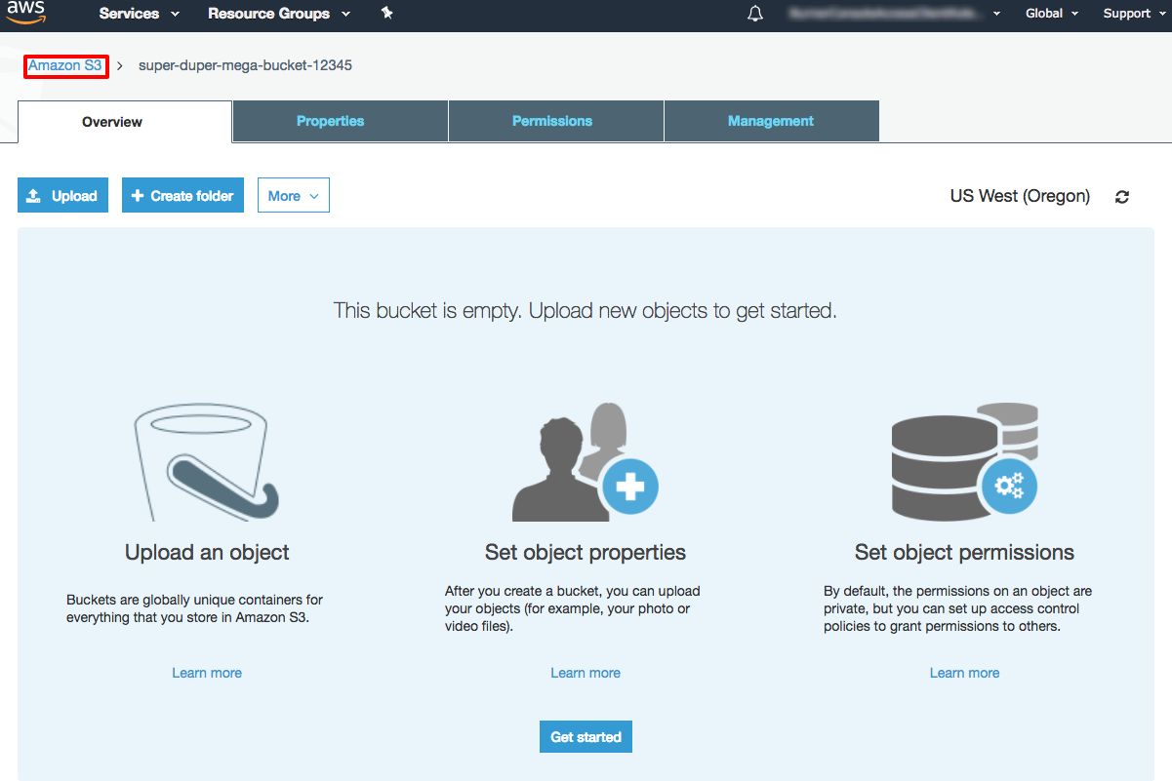

(click to zoom)